Amitriptyline HCl
Taj Active Pharmaceuticals Ingredients |  | www.tajapi.com
 |   Raw Material / Chemicals Index
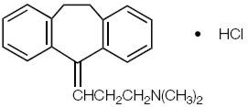

Product: Amitriptyline HCl
CAS: 549-18-8
Synonym:
Formula: C20H 23N·HCl
Class: Active Pharmaceutical ingredients (APIs)
Product Type: Hazard:
SPECIFICATIONS
Assay : |  | 99.0 - 100.5%
Identification : |  | To pass IR and UV Tests
Melting Range : |  | between 195° and 199°
pH : |  | 5.0 - 6.0
Loss on Drying : |  | not more than 0.5%
Residue on Ignition : |  | not more than 0.1%
Heavy Metals : |  | not more than 0.001%
Organic Volatile Impurities : |  | meets the requirements

