Atorvastatin Calcium (Cas No 134523-00-5)
Taj Active Pharmaceuticals Ingredients |  | www.tajapi.com
 |   Raw Material / Chemicals Index
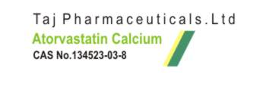
Chemical Formulas
Systematic (IUPAC) name
(3R,5R)-7-[2-(4-fluorophenyl)-3-phenyl-4-(phenylcarbamoyl)-5-(propan-2-yl)-1H-pyrrol-1-yl]-3,5-dihydroxyheptanoic acid
Identifiers
CAS number 134523-00-5
ATC code C10AA05
PubChem 60823
DrugBank APRD00055
ChemSpider 54809
Chemical data
Formula C33H35FN2O5
Mol. mass 558.64
SMILES eMolecules & PubChem
Pharmacokinetic data
Bioavailability 12%
Metabolism Hepatic - CYP3A4
Half life 14 hours
Excretion Bile
Therapeutic considerations
Pregnancy cat.
Routes oral
Atorvastatinis a member of the drug class known as statins, used for lowering blood cholesterol.
It also stabilizes plaque and prevents strokes through anti-inflammatory and other mechanisms.Atorvastatin inhibits HMG-CoA reductase, the rate-determining enzyme located in hepatic tissue that produces mevalonate, a small molecule used in the synthesis of cholesterol and other mevalonate derivatives.
This lowers the amount of cholesterol produced which in turn lowers the total amount of LDL cholesterol.

