BICALUTAMIDE (Cas No 90357-06-5 )
Taj Active Pharmaceuticals Ingredients |  | www.tajapi.com
 |   Raw Material / Chemicals Index

GENERIC NAME: BICALUTAMIDE-ORAL (bye-kah-LEW-tuh-mide)
The structural and empirical formulas are:
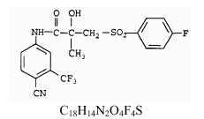
CAS number 90357-06-5
Chemical data
Formula C18H14F4N2O4S
Mol. mass 430.373 g/mol
Bicalutamide has a molecular weight of 430.37.
The pKa' is approximately 12.
Bicalutamide is a fine white to off-white powder which is practically insoluble in water at 37° C (5 mg per 1000 mL), slightly soluble in chloroform and absolute ethanol, sparingly soluble in methanol, and soluble in acetone and tetrahydrofuran.
The chemical name is propanamide,
N-[4-cyano-3-(trifluoromethyl)phenyl]-3-[(4-fluorophenyl)sulfonyl]-2-hydroxy-2-methyl-,(+-).

