Balsalazide
Taj Active Pharmaceuticals Ingredients |  | www.tajapi.com
 |   Raw Material / Chemicals Index

structural formula is:
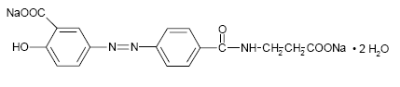
Molecular Formula: C₁₇H₁₃N₃O₆Na₂•2H₂O
CAS number 80573-04-2
ATC code A07EC04
PubChem 5362070
DrugBank APRD00141
Molecular Weight: 437.32
Mol. mass 357.318 g/mol
Balsalazide disodium is a stable, odorless orange to yellow microcrystalline powder. It is freely soluble in water and isotonic saline, sparingly soluble in methanol and ethanol, and practically insoluble in all other organic solvents.

