Betamethasone
CAS number 378-44-9
Taj Active Pharmaceuticals Ingredients |  | www.tajapi.com
 |   Raw Material / Chemicals Index

Systematic (IUPAC) name
(8S,9R,10S,11S,13S,14S,16S,17R)-9-fluoro- 11,17-dihydroxy-17-(2-hydroxyacetyl)-10,13,16-trimethyl-6,7,8,9,10,11,12,13,14,15,16,17-dodecahydro-3H-cyclopenta[a]phenanthren-3-one
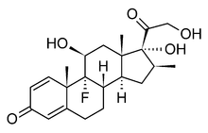
Identifiers
CAS number 378-44-9
ATC code A07EA04 C05AA05 D07AC01 D07XC01 H02AB01 R01AD06 R03BA04 S01BA06
S01CB04 S02BA07 S03BA03
PubChem CID 9782
DrugBank APRD00513
ChemSpider 9399
UNII 9842X06Q6M
Chemical data
Formula C22H29FO5
Mol. mass 392.461
SMILES eMolecules & PubChem
What is Betamethasone?
Betamethasone is in a class of drugs called steroids. It reduces swelling and decreases the body's immune response. This medicine is used to treat many different conditions. Primarily, it is used to treat endocrine (hormonal) disorders when the body does not produce enough of its own steroids. It is also used to treat many immune and allergic disorders, such as arthritis, lupus, psoriasis, asthma, ulcerative colitis, and Crohn's disease.
Product Information
The sections below will provide you with more specific information and guidelines related to betamethasone and its correct use. Please read them carefully.
FDA Information
Betamethasone was first approved by the FDA in 1961. A foam formulation of betamethasone valerate (Luxiq®) was approved on February 28th 1999 for corticosteroid-responsive scalp dermatoses. Please visit the official site of the FDA for further information.
Why is this medication prescribed?
Betamethasone is a kind of topical corticosteroids commonly prescribed for the treatment of skin and scalp disorders such as arthritis, asthma, ulcerative colitis, severe psoriasis, itching, redness, dryness, crusting, scaling, eczema, and inflammation.
Corticosteroids are anti-inflammatory medicines. Inflammation of the skin happens due to the irritation of the skin, and is caused by the release of various substances that are important in the immune system. These substances cause blood vessels to widen, resulting in the irritated area becoming red, swollen, itchy and painful. Betamethasone works by acting inside the skin cells to decrease the release of these inflammatory substances.
Other uses for this medicine
This medication has not been approved for any alternative uses other than those mentioned in the product information section.
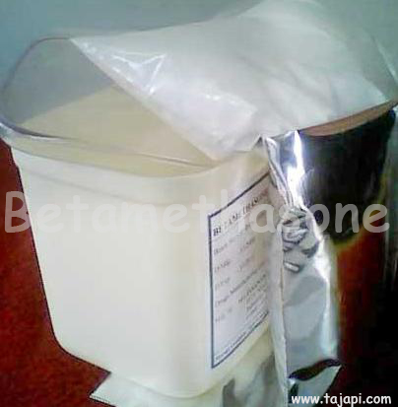
What is the dosage and how should it be used?
Betamethasone comes in ointment, cream, lotion, and aerosol (spray) in various strengths for use on the skin.
Take betamethasone exactly as directed by your doctor. Do not take more or less than is prescribed for you and if you do not understand these directions, ask your pharmacist, nurse, or doctor to explain them to you.
Take each dose with a full glass of water, as well as with food or milk to lessen stomach upset.
Be sure to measure the liquid with the dropper provided or with a special dose-measuring spoon or cup. Ask your pharmacist for a dose-measuring spoon or cup if you do not have one.
Additionally, if you are taking one dose daily, take that dose before 9 a.m. if possible, to follow the body's natural cycle. If you take more than one dose daily, space the doses evenly throughout the day as directed by your doctor.
Do not stop taking betamethasone suddenly if you have been taking it for a few weeks. You may need a gradual reduction in dosage before you stop taking this medication.
It is strongly advised that you carry some type of medical identification that will let others know you are taking betamethasone in the case of an emergency.
What side effects can this medication cause?
If you experience any of the following serious side effects, stop taking betamethasone and seek emergency medical attention or contact your doctor immediately:
an allergic reaction (difficulty breathing; closing of your throat; swelling of your lips, tongue, or face; or hives)
increased blood pressure (severe headache or blurred vision)
sudden weight gain (more than 5 pounds in a day or two)
Other, less serious side effects may be more likely to occur. Continue to take betamethasone and talk to your doctor if you experience:
insomnia
nausea, vomiting, or stomach upset
fatigue or dizziness
muscle weakness or joint pain
problems with diabetes control
increased hunger or thirst
Other side effects that occur only rarely, usually with high doses of betamethasone, include:
acne
increased hair growth
thinning of the skin
cataracts
glaucoma
osteoporosis
roundness of the face
changes in behavior
Side effects other than those listed here may also occur. Talk to your doctor about any side effect that seems unusual or that is especially bothersome.
What storage conditions are needed for this medicine?
Always keep this medication in the container it came in, tightly closed, and out of reach of children. Store it according to the package instructions.
Please remeber to throw away any medication that is outdated or no longer needed. If it is necessary, talk to your pharmacist about the proper disposal of your medication.
Never use it to treat other skin conditions.
In case of emergency/overdose
In the case of an overdose, call your local poison control center at 1-800-222-1222. If the victim has collapsed or is not breathing, then call the local emergency services on 911.Symptoms of overdose may include:
acne
bruising
obesity (especially around the stomach)
a round face
increased hair growth (especially around the face)
increased blood pressure
swollen hands, feet, or ankles (fluid retention)
sore or weak muscles

