Budesonide (Cas No 51333-22-3 )
Taj Active Pharmaceuticals Ingredients |  | www.tajapi.com
 |   Raw Material / Chemicals Index

CAS number 51333-22-3
ATC code A07EA06 D07AC09, R01AD05, R03BA02
structural formula is:
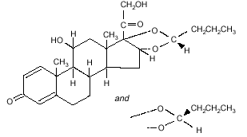
Formula C25H34O6
Mol. mass 430.534 g/mol
SMILES eMolecules & PubChem
Its partition coefficient between octanol and water at pH 5 is 1.6 x 10.3
Pharmacokinetic data
Bioavailability 100% (but large first pass effect)
Protein binding 85-90%
Metabolism Hepatic CYP3A4
Half life 2.0-3.6 hours
Excretion Renal, Faecal
Chemical data
Budesonide is designated chemically as
(RS)-11-beta, 16-alpha, 17, 21-tetrahydroxypregna-1,
4-diene-3,20-dione cyclic 16, 17-acetal with butyraldehyde.
Budesonide is provided as the mixture of two epimers (22R and 22S).
The empirical formula of budesonide is C25H34O6 and its molecular weight is 430.5.
Budesonide is a white to off-white, odorless powder that is practically insoluble in water and in heptane,
sparingly soluble in ethanol, and freely soluble in chloroform.

