Buprenorphine Hcl (Cas No 53152-21-9)
Taj Active Pharmaceuticals Ingredients |  | www.tajapi.com
 |   Raw Material / Chemicals Index

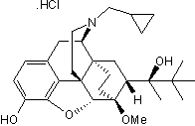
Buprenorphine HCl
Chemical Name: [5a,7a(S)]-17-(Cyclopropylmethyl)-a-(1,1-dimethylethyl) -4,5-epoxy-18,19-dihydro-3-hydroxy-6-methoxy-a-methyl-6 ,14-ethenomorphinan-7-methanol hydrochloride
Clinical Data
M.Wt: 504.1
Formula: C29H41NO4.HCl
Solubility: Soluble to 25 mM in Water and to 50 mM in Ethanol
Purity: >99 %
Storage: Store at RT
CAS No: [53152-21-9]

