Capecitabine (Cas No 154361-50-9 )
Taj Active Pharmaceuticals Ingredients |  | www.tajapi.com
 |   Raw Material / Chemicals Index

Capecitabine is a chemotherapy drug that is given as a treatment for some types of cancer, including advanced bowel cancer or breast cancer.
Chemical Name:
pentyl[1-(3,4-dihydroxy-5-methyl-tetrahydrofuran-2-yl)- 5-fluoro-2-oxo-1H-pyrimidin- 4-yl]aminomethanoate
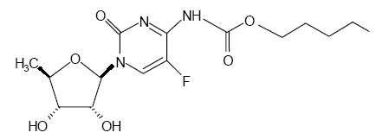Description
CAS number | 154361-50-9
Synonym | 5'-deoxy-5-fluoro-N-[(pentyloxy) carbonyl]- cytidine, Capecitabine
Molecular Formula | C15H22FN3O6
Molecular Weight | 359.35
Specifications | Available on request
Packing | Export worthy packing
Application | Chemotherapy drug
Material Safety Data Sheet | Available on request
Availability | For your requirements of evaluation, Pilots and Commercial procurement

