Carboplatin (Cas No 41575-94-4)
Taj Active Pharmaceuticals Ingredients |  | www.tajapi.com
 |   Raw Material / Chemicals Index

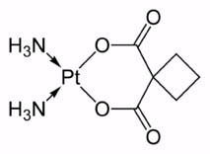
CAS number 41575-94-4
ATC code L01XA02
PubChem 498142
DrugBank APRD00466
Carboplatin
Systematic (IUPAC) name
azanide; cyclobutane-1,1-dicarboxylic acid; platinum
Chemical data
Formula C6H14N2O4Pt
Mol. mass 371.249 g/mol
Pharmacokinetic data
Bioavailability complete
Protein binding Very low
Metabolism ?
Half life 1.1-2 hours
Excretion hepatic
Therapeutic considerations
Pregnancy cat.
D(US)
Legal status
Routes Intravenous

