Carvedilol (Cas No 72956-09-3)
Taj Active Pharmaceuticals Ingredients |  | www.tajapi.com
 |   Raw Material / Chemicals Index

Molecular Structure
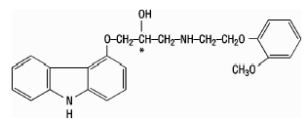
CAS No [72956-09-3]
Chemical Name 1-(9H-Clarbazol-4-yloxy)-3-[[2-(2-methoxyphenoxy)ethyl[amino]-2-propanol
BM-14190
DQ-2466
Coreg
Dilatrend
Dimitone
Eucardic
Kredex
Querto
Molecular Formula C24H26N2O4 / C24H26N2O4
Molecular Weight 406.47
Therapeutic Category Anihypertensive; in treatment of congestive heart failure.

