Cefdinir (Cas No 91832-40-5)
Taj Active Pharmaceuticals Ingredients |  | www.tajapi.com
 |   Raw Material / Chemicals Index

Cefdinir
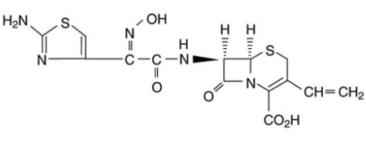
Systematic (IUPAC) name
8-[2-(2-amino-1,3-thiazol-4-yl)-1-hydroxy-2-nitroso-
ethenyl]amino-4-ethenyl-7-oxo-2-thia-6-
azabicyclo[4.2.0]oct-4-ene-5-carboxylic acid
Identifiers
CAS number 91832-40-5
ATC code J01DD15
PubChem 6399253
DrugBank APRD00644
Chemical data
Formula C14H13N5O5S2
Mol. mass 395.416 g/mol
SMILES eMolecules & PubChem
Pharmacokinetic data
Bioavailability 16% to 21% (dose-dependent)
Protein binding 60% to 70%
Metabolism Negligible
Half life 1.7 ± 0.6 hours
Excretion Renal
Cefdiniris a semi-synthetic, broad-spectrum antibiotic in the third generation of the cephalosporin class, proven effective for common bacterial infections of the ear, sinus, throat, and skin.
Cefdinir is an antibiotic used to treat certain infections caused by bacteria, such as pneumonia, bronchitis, ear infections, sinusitis, pharyngitis, tonsillitis, and skin infections. Antibiotics will not work for colds, flu, or other viral infections.

