Cefixime (Cas No 79350-37-1)
Taj Active Pharmaceuticals Ingredients |  | www.tajapi.com
 |   Raw Material / Chemicals Index

Cefixime
CAS number 79350-37-1
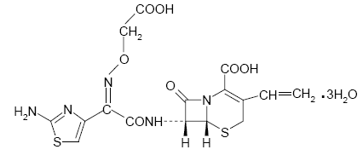
Systematic (IUPAC) name
(6R,7R)-7-{[2-(2-amino-1,3-thiazol-4-yl)-2-(carboxy
methoxyimino)acetyl]amino}-3-ethenyl-8-oxo-5-thia-
1-azabicyclo[4.2.0]oct-2-ene-2-carboxylic acid
Identifiers
CAS number 79350-37-1
ATC code J01DD08
PubChem 54362
DrugBank APRD00583
Chemical data
Formula C16H15N5O7S2
Mol. mass 453.452 g/mol
Pharmacokinetic data
Bioavailability 40% to 50%
Protein binding Approximately 60%
Half life Variable
Average 3 to 4 hours
Excretion Renal and biliary
Cefixime is a cephalosporin antibiotic used to treat infections caused by bacteria such as pneumonia; bronchitis; gonorrhea; and ear, lung, throat, and urinary tract infections. Antibiotics will not work for colds, flu, or other viral infections.

