Cefprozil (Cas No 66592-87-8)
Taj Active Pharmaceuticals Ingredients |  | www.tajapi.com
 |   Raw Material / Chemicals Index

Cefprozil
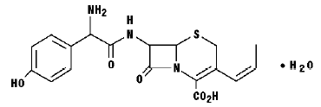
Systematic (IUPAC) name
(6R,7R)-7-{[(2R)-2-amino-2-(4-hydroxyphenyl)acetyl]amino}-3-methyl-8-oxo-5-thia-1-azabicyclo[4.2.0]oct-2-ene-2-carboxylic acid
Identifiers
CAS number 66592-87-8
ATC code J01DB05
PubChem 2610
DrugBank APRD00196
Chemical data
Formula C16H17N3O5S
Mol. mass 363.389 g/mol
SMILES eMolecules & PubChem
Pharmacokinetic data
Protein binding plasma protein
Metabolism unknown
Half life 1.5 hours
Cefprozil, sometimes spelled cefproxil and sold under the brand name Cefzil, is a cephalosporin type antibiotic.

