Cefradine (Cas No 38821-53-3)
Taj Active Pharmaceuticals Ingredients |  | www.tajapi.com
 |   Raw Material / Chemicals Index

Cefradine
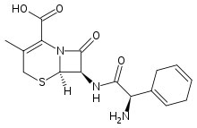
Systematic (IUPAC) name
(6R,7R)-7-{[(2R)-2-amino-2-(1-cyclohexa-1,4-
dienyl)acetyl]amino}-3-methyl-8-oxo-5-thia-
1-azabicyclo[4.2.0]oct-2-ene-2-carboxylic acid
Identifiers
CAS number 38821-53-3
ATC code J01DB09
PubChem 38103
Chemical data
Formula C16H19N3O4S
Mol. mass 349.406 g/mol
Pharmacokinetic data
Bioavailability Well absorbed
Protein binding <10%
Metabolism Nil
Half life 0.9 hours
Excretion Renal, unchanged
Cefradine works by killing or stopping the growth of the bacteria that cause infections. It is a broad spectrum antibiotic which means it is active against a wide variety of bacteria.

