Ceftibuten (Cas No 97519-39-6)
Taj Active Pharmaceuticals Ingredients |  | www.tajapi.com
 |   Raw Material / Chemicals Index

Ceftibuten
CAS number 97519-39-6
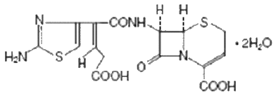
Systematic (IUPAC) name
(6R,7R)-7-([(Z)-2-(2-amino-1,3-thiazol-4-yl)-5-hydroxy-5-oxopent-2-enoyl]amino) -8-oxo-5-thia-1-azabicyclo[4.2.0]oct-2-ene-2-carboxylic acid
Identifiers
CAS number 97519-39-6
ATC code J01DD14
PubChem 5282242
Chemical data
Formula C15H14N4O6S2
Mol. mass 410.427 g.mol-1
Ceftibuten is a third-generation cephalosporin antibiotic.
ceftibutencontain the active ingredient ceftibuten as ceftibuten dihydrate. Ceftibuten dihydrate is a semisynthetic cephalosporin antibiotic for oral administration. Chemically, it is (+)-(6R,7R)-7-[(Z)-2-(2-Amino-4-thiazolyl)-4-carboxycrotonamido]-8-oxo-5-thia-1-azabicyclo[4.2.0]oct-2-ene-2-carboxylic acid, dihydrate. Its molecular formula is C15H14N4O6S2•2H2O. Its molecular weight is 446.43 as the dihydrate.
Ceftibuten is a cephalosporin antibiotic used to treat certain infections caused by bacteria such as bronchitis and ear and throat infections. Antibiotics will not work for colds, flu, or other viral infections.

