Cefuroxime Axetil (Cas No 55268-75-2)
Taj Active Pharmaceuticals Ingredients |  | www.tajapi.com
 |   Raw Material / Chemicals Index

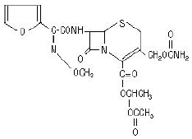
CAS number 55268-75-2
Formula C16H16N4O8S
Mol. mass 424.386 g/mol
ATC code J01DC02
PubChem 41375
DrugBank APRD00285
ChemSpider 4514699
Pharmacokinetic data
Bioavailability 37% on empty stomach, up to 52% if taken after food
Metabolism axetil moiety is metabolized to acetaldehyde and acetic acid
Half life 80 minutes
Excretion Urine 66-100% Unchanged
Systematic (IUPAC) name
4-(carbamoyloxymethyl)-8- [2-(2-furyl)-2-methoxyimino-acetyl]amino -7-oxo-
2-thia-6-azabicyclo[4.2.0]oct -4-ene-5-carboxylic acid
Chemically, cefuroxime axetil, the 1-(acetyloxy) ethyl ester of cefuroxime, is (RS)-1-hydroxyethyl (6R,7R)-7-[2-(2-furyl)glyoxyl-amido]-3-(hydroxymethyl)-8-oxo-5-thia-1-azabicyclo[4.2.0]-oct-2-ene-2-carboxylate, 72-(Z)-(O-methyl-oxime), 1-acetate 3-carbamate. Its molecular formula is C20H22N4O10S, and it has a molecular weight of 510.48.

