Clomipramine (Cas No 17321-77-6)
Taj Active Pharmaceuticals Ingredients |  | www.tajapi.com
 |   Raw Material / Chemicals Index

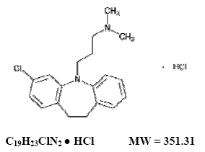
Clomipramine
Systematic (IUPAC) name
3-(3-chloro-10,11-dihydro-5H-dibenzo[b,f]azepin-5-yl)-N,N-dimethylpropan-1-amine
Identifiers
CAS number 17321-77-6
ATC code N06AA04
PubChem 2801
DrugBank APRD00253
ChemSpider 2699
Chemical data
Formula C19H23ClN2
Mol. mass 314.9
Pharmacokinetic data
Bioavailability Oral ~50%
Metabolism Hepatic
Half life Clomipramine ~35 hours
Desmethylclomipramine (main active metabolite) ~50 hours
Excretion Renal

