Clopidogrel Bisulfate (Cas No 135046-48-9)
Taj Active Pharmaceuticals Ingredients |  | www.tajapi.com
 |   Raw Material / Chemicals Index

structural formula is as follows:
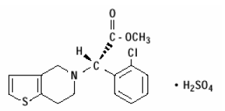
Clopidogrel Bisulfate
CAS number 135046-48-9
ATC code B01AC04
PubChem 60606
DrugBank APRD00444
ChemSpider 54632
Chemical data
Formula C16H16ClNO2S
Mol. mass 321.82 g/mol
SMILES eMolecules & PubChem
Pharmacokinetic data
Bioavailability >50%
Protein binding 94–98%
Metabolism Hepatic
Half life 7–8 hours (inactive metabolite)
Excretion 50% renal
46% biliary

