Codeine base (Cas No 76-57-3)
Taj Active Pharmaceuticals Ingredients |  | www.tajapi.com
 |   Raw Material / Chemicals Index

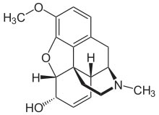
Codeine base
CAS number 76-57-3
ATC code R05DA04 N02AA59
Chemical data
Formula C18H21NO3
Mol. mass 299.364 g/mol
Pharmacokinetic data
Bioavailability ~90% Oral
Metabolism Hepatic, via CYP2D6 (Cytochrome P450 2D6)[1]
Half life 2.5–3 hours

