Codeine phosphate (Cas No 41444-62-6)
Taj Active Pharmaceuticals Ingredients |  | www.tajapi.com
 |   Raw Material / Chemicals Index

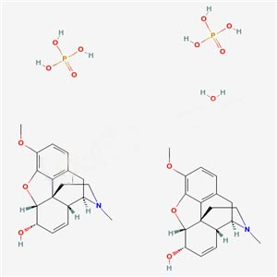
Codeine phosphate hemihydrate
Synonyms:Codeine phosphate (TN)
Codeine phosphate (JP14/USP)
CAS Number:41444-62-6
Molecular Formula:C36H50N2O15P2
Mol weight : 406.4
Particle Size mind.95%<0.1 mm
Codeine phosphate is a centrally active analgesic. When administered parenterally, 120 mg of codeine phosphate produces an analgesic response equivalent to that from 10 mg of morphine. Other actions include respiratory depression; depression of the cough center; release of antidiuretic hormone; activation of the vomiting center; pupillary constriction; a decrease in gastric, pancreatic, and biliary secretion; a reduction in intestinal motility; an increase in biliary tract pressure; and an increased amplitude of ureteral contractions.

