Desmopressin Monoacetate (Cas No 62288-83-9)
Taj Active Pharmaceuticals Ingredients |  | www.tajapi.com
 |   Raw Material / Chemicals Index

Molecular Structure
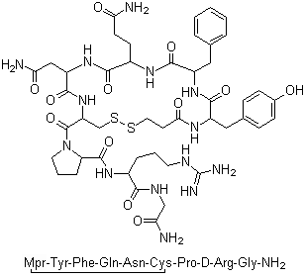
Desmopressin Monoacetate
Molecular Formula C46H64N14O12S2
Molecular Weight 1069.22
CAS Number 62288-83-9
EINECS 240-726-7
Pharmacokinetic data
Bioavailability Variable; 0.08–0.16% (oral)
Protein binding 50%
Metabolism ?
Half life 1.5–2.5 hours
Excretion Renal
Therapeutic considerations
Pregnancy cat.
B2(AU) B(US)
Legal status
POM(UK) ℞-only(US)
Routes IV, IM, SC, intranasal, oral

