Dexamethasone
CAS number 50-02-2
Taj Active Pharmaceuticals Ingredients |  | www.tajapi.com
 |   Raw Material / Chemicals Index

Systematic (IUPAC) name
(8S,9R,10S,11S,13S,14S,16R,17R)-9-Fluoro-11,17-dihydroxy-17-(2-hydroxyacetyl)-10,13,16-trimethyl-6,7,8,9,10,11,12,13,14,15,16,17- dodecahydro-3H-cyclopenta[a]phenanthren-3-one
Identifiers
CAS number 50-02-2
ATC code A01AC02 C05AA09, D07AB19, H02AB02, R01AD03, S01BA01, S02BA06, S03BA01
PubChem CID 5743
DrugBank APRD00674
ChemSpider 5541
UNII 7S5I7G3JQL
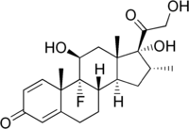
Chemical data
Formula C22H29FO5
Mol. mass 392.461 g/mol
SMILES eMolecules & PubChem
Pharmacokinetic data
Bioavailability 80-90%
Protein binding 70%
Metabolism hepatic
Half-life 36-54 hours
Excretion renal
Therapeutic considerations
Pregnancy cat. C(US)
Legal status Prescription only
Routes Oral, IV, IM, SC and IO
(dexamethasone tablets, USP) tablets, for oral administration, are supplied in two potencies, 0.5 mg and 0.75 mg. Inactive ingredients are calcium phosphate, lactose, magnesium stearate, and starch. Tablets 0.5 mg also contain D&C Yellow 10 and FD&C Yellow 6. Tablets 0.75 mg also contain FD&C Blue 1.
The molecular weight for dexamethasone is 392.47. It is designated chemically as 9-fluoro-11β,17,21-trihydroxy-16α-methylpregna-1,4-diene-3,20-dione. The empirical formula is C22H29FO5 and the structural formula is:
dexamethasone structural formula illustration
Dexamethasone, a synthetic adrenocortical steroid, is a white to practically white, odorless, crystalline powder. It is stable in air. It is practically insoluble in water.
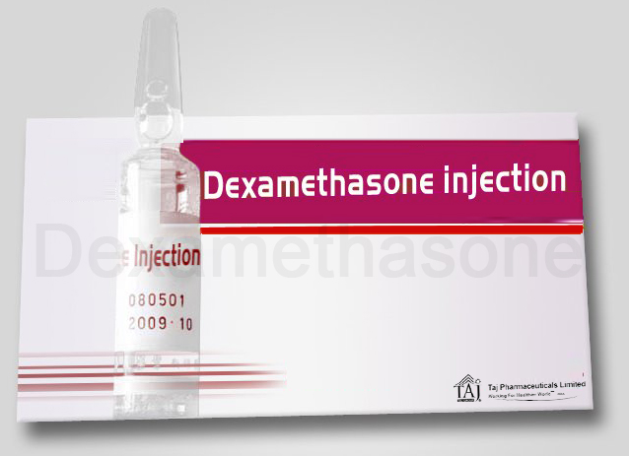
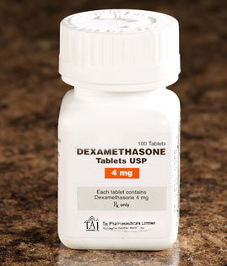
INDICATIONS
Allergic states: Control of severe or incapacitating allergic conditions intractable to adequate trials of conventional treatment in asthma, atopic dermatitis, contact dermatitis, drug hypersensitivity reactions, perennial or seasonal allergic rhinitis, and serum sickness.
Dermatologic diseases: Bullous dermatitis herpetiformis, exfoliative erythroderma, mycosis fungoides, pemphigus, and severe erythema multiforme (Stevens-Johnson syndrome).
Endocrine disorders: Primary or secondary adrenocortical insufficiency (hydrocortisone or cortisone is the drug of choice; may be used in conjunction with synthetic mineralocorticoid analogs where applicable; in infancy mineralocorticoid supplementation is of particular importance), congenital adrenal hyperplasia, hypercalcemia associated with cancer, and nonsuppurative thyroiditis.
Gastrointestinal diseases: To tide the patient over a critical period of the disease in regional enteritis and ulcerative colitis.
Hematologic disorders: Acquired (autoimmune) hemolytic anemia, congenital (erythroid) hypoplastic anemia (Diamond-Blackfan anemia), idiopathic thrombocytopenic purpura in adults, pure red cell aplasia, and selected cases of secondary thrombocytopenia.
Miscellaneous: Diagnostic testing of adrenocortical hyperfunction, trichinosis with neurologic or myocardial involvement, tuberculous meningitis with subarachnoid block or impending block when used with appropriate antituberculous chemotherapy.
Neoplastic diseases: For the palliative management of leukemias and lymphomas.
Nervous system: Acute exacerbations of multiple sclerosis, cerebral edema associated with primary or metastatic brain tumor, craniotomy, or head injury.
Ophthalmic diseases: Sympathetic ophthalmia, temporal arteritis, uveitis, and ocular inflammatory conditions unresponsive to topical corticosteroids.
Renal diseases: To induce a diuresis or remission of proteinuria in idiopathic nephrotic syndrome or that due to lupus erythematosus.
Respiratory diseases: Berylliosis, fulminating or disseminated pulmonary tuberculosis when used concurrently with appropriate antituberculous chemotherapy, idiopathic eosinophilic pneumonias, symptomatic sarcoidosis.
Rheumatic disorders: As adjunctive therapy for short-term administration (to tide the patient over an acute episode or exacerbation) in acute gouty arthritis, acute rheumatic carditis, ankylosing spondylitis, psoriatic arthritis, rheumatoid arthritis, including juvenile rheumatoid arthritis (selected cases may require low-dose maintenance therapy). For the treatment of dermatomyositis, polymyositis, and systemic lupus erythematosus.
DOSAGE AND ADMINISTRATION
For oral administration
The initial dosage varies from 0.75 to 9 mg a day depending on the disease being treated.
It Should Be Emphasized That Dosage Requirements Are Variable And Must Be Individualized On The Basis Of The Disease Under Treatment And The Response Of The Patient.
After a favorable response is noted, the proper maintenance dosage should be determined by decreasing the initial drug dosage in small decrements at appropriate time intervals until the lowest dosage that maintains an adequate clinical response is reached.
Situations which may make dosage adjustments necessary are changes in clinical status secondary to remissions or exacerbations in the disease process, the patient's individual drug responsiveness, and the effect of patient exposure to stressful situations not directly related to the disease entity under treatment. In this latter situation it may be necessary to increase the dosage of the corticosteroid for a period of time consistent with the patient's condition. If after long-term therapy the drug is to be stopped, it is recommended that it be withdrawn gradually rather than abruptly.
In the treatment of acute exacerbations of multiple sclerosis, daily doses of 30 mg of dexamethasone for a week followed by 4 to 12 mg every other day for one month have been shown to be effective (see PRECAUTIONS, Neuro-psychiatric).
In pediatric patients, the initial dose of dexamethasone may vary depending on the specific disease entity being treated. The range of initial doses is 0.02 to 0.3 mg/kg/day in three or four divided doses (0.6 to 9 mg/m2bsa/day).
For the purpose of comparison, the following is the equivalent milligram dosage of the various corticosteroids:
Cortisone, 25 Triamcinolone, 4
Hydrocortisone, 20 Paramethasone, 2
Prednisolone, 5 Betamethasone, 0.75
Prednisone, 5 Dexamethasone, 0.75
Methylprednisolone, 4
These dose relationships apply only to oral or intravenous administration of these compounds. When these substances or their derivatives are injected intramuscularly or into joint spaces, their relative properties may be greatly altered.
In acute, self-limited allergic disorders or acute exacerbations of chronic allergic disorders, the following dosage schedule combining parenteral and oral therapy is suggested:
Dexamethasone Sodium Phosphate injection, USP 4 mg per mL
First Day
1 or 2 mL, intramuscularly tablets, 0.75 mg:
Second Day
4 tablets in two divided doses
Third Day
4 tablets in two divided doses
Fourth Day
2 tablets in two divided doses
Fifth Day
1 tablet
Sixth Day
1 tablet
Seventh Day
No treatment
Eighth Day
Follow-up visit
This schedule is designed to ensure adequate therapy during acute episodes, while minimizing the risk of overdosage in chronic cases.
In cerebral edema, Dexamethasone Sodium Phosphate injection, USP is generally administered initially in a dosage of 10 mg intravenously followed by 4 mg every six hours intramuscularly until the symptoms of cerebral edema subside. Response is usually noted within 12 to 24 hours and dosage may be reduced after two to four days and gradually discontinued over a period of five to seven days. For palliative management of patients with recurrent or inoperable brain tumors, maintenance therapy with either Dexamethasone Sodium Phosphate injection, USP or tablets in a dosage of 2 mg two or three times daily may be effective. Dexamethasone suppression tests.
Tests for Cushing's syndrome
Give 1.0 mg of orally at 11:00 p.m. Blood is drawn for plasma cortisol determination at 8:00 a.m. the following morning.For greater accuracy, give 0.5 mg of orally every 6 hours for 48 hours. Twenty-four hour urine collections are made for determination of 17-hydroxycorticosteroid excretion.Test to distinguish Cushing's syndrome due to pituitary ACTH excess from Cushing's syndrome due to other causes.Give 2.0 mg of orally every 6 hours for 48 hours. Twenty-four hour urine collections are made for determination of 17-hydroxycorticosteroid excretion.
HOW SUPPLIED
Tablets are compressed, pentagonal-shaped tablets, colored to distinguish potency. They are scored and coded on one side and embossed with on the other. They are available as follows:
Standard I.P./B.P./U.S.P.
Category Corticosteroid
Packing 250gm/500gm/1000gm
Preparation Tablets, Injections, Eye & Ear drops etc
Storage Store in a well closed light resistant container in cool and dry place.

