Dihydrocodeine hydrogen tartrate (Cas No 5965-13-9)
Taj Active Pharmaceuticals Ingredients |  | www.tajapi.com
 |   Raw Material / Chemicals Index
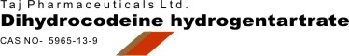
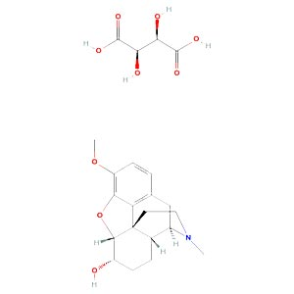
Dihydrocodeine hydrogen tartrate
Synonyms:Paracodeine bitartrate
Morphinan-6-ol, 4,5-epoxy-3-methoxy-17-methyl-, (5.alpha.,6.alpha.)-, [R-(R*,R*)]-2,3-dihydroxybutanedioate (1:1) (salt)
Codeine, dihydro-, tartrate (1:1) (6CI,7CI)
Hydrocodeine hydrogen tartrate
4,5alpha-Epoxy-6alpha-hydroxy-3-methoxy-17-methylmorphinan hydrogen (R-(R*,R*))-tartrate
Dihydrocodeine bitartrate
Tuscodin
Morphinan-6alpha-ol, 4,5alpha-epoxy-3-methoxy-17-methyl-, tartrate (1:1) (salt) (8CI)
Morphinan-6.alpha.-ol, 4, 5.alpha.-epoxy-3-methoxy-17-methyl-, tartrate (1:1) (salt)
Morphinan-6-alpha-ol, 4,5-alpha-epoxy-3-methoxy-17-methyl-, tartrate (1:1)
CAS Number:5965-13-9
Molecular Formula:C18H23NO3
Molecular Weight:451.47
EINECS:204-732-3
Density:1.31 g/cm3
Boiling Point:462 °C at 760 mmHg

