Dobutamine (Cas No 52663-81-7)
Taj Active Pharmaceuticals Ingredients |  | www.tajapi.com
 |   Raw Material / Chemicals Index

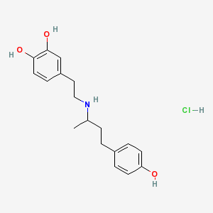
Dobutamine
IUPAC Name 4-[2-[4-(4-hydroxyphenyl)butan-2-ylamino]ethyl]benzene-1,2-diol hydroc
hloride
CAS Number 52663-81-7
Chemical Formula C18H24ClNO3
Molecular Weight 337.84106 [g/mol
Molecular Formula C18H24ClNO3
INGREDIENTS
Name (Active Moiety) Type Strength
Dobutamine Hydrochloride (Dobutamine) Active 12.5 MILLIGRAM In 1 MILLILITER
Sodium Metabisulfite Inactive 0.2 MILLIGRAM In 1 MILLILITER
Hydrochloric Acid Inactive
Sodium Hydroxide Inactive

