Dothiepin Hcl (CAS NO 113-53-1)
Taj Active Pharmaceuticals Ingredients |  | www.tajapi.com
 |   Raw Material / Chemicals Index

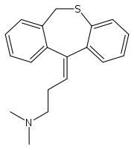
Dothiepin Hcl
CAS number 113-53-1
ATC code N06AA16
PubChem 13473
Chemical data
Formula C19H21NS
Mol. mass 331.9 g/mol
Pharmacokinetic data
Bioavailability 30%
Metabolism Hepatic
Half life 20 hours
Excretion Renal
Therapeutic considerations
Pregnancy cat.
methanol and ethanol, and practically insoluble in all other organic solvents.

