Doxazosin Mesylate (Cas No 74191-85-8)
Taj Active Pharmaceuticals Ingredients |  | www.tajapi.com
 |   Raw Material / Chemicals Index

Doxazosin Mesylate
CAS number 74191-85-8
Structural Formula :
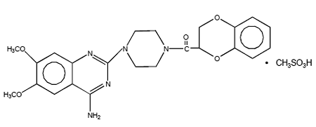
Doxazosin Mesylatea quinazoline compoundis an alpha blocker used to treat high blood pressure and benign prostatic hyperplasia.
Systematic (IUPAC) name
2-{4-[(2,3-dihydro-1,4-benzodioxin-2-yl)carbonyl]piperazin-1-yl}-6,7-dimethoxyquinazolin-4-amine
Identifiers
CAS number 74191-85-8
ATC code C02CA04
PubChem 3157
DrugBank APRD00474
Chemical data
Formula C23H25N5O5
Mol. mass 451.475 g/mol
Pharmacokinetic data
Bioavailability 65%
Protein binding 98%
Metabolism Hepatic
Half life 22 hours

