Duloxetine Hcl (Cas No 136434-34-9)
Taj Active Pharmaceuticals Ingredients |  | www.tajapi.com
 |   Raw Material / Chemicals Index
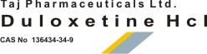
Duloxetine HCl
CAS number 136434-34-9
Structural Formula :
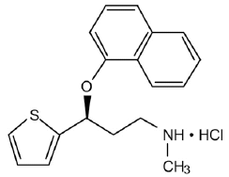
Systematic (IUPAC) name
(+)-(S)-N-Methyl-3-(naphthalen-1-yloxy)-
3-(thiophen-2-yl)propan-1-amine
Identifiers
CAS number 116539-59-4 (free base). 136434-34-9 (hydrochloride)
ATC code N06AX21
PubChem 60835
DrugBank APRD00060
ChemSpider 54822
Chemical data
Formula C18H19NOS
Mol. mass 297.41456 g/mol
SMILES eMolecules & PubChem
Pharmacokinetic data
Bioavailability ~ 50% (32% to 80%)
Protein binding ~ 95%
Metabolism Liver, two P450 isozymes, CYP2D6 and CYP1A2.
Half life 12,1 hours
Excretion 70% in urine, 20% in feces

