Dutasteride (Cas No 164656-23-9)
Taj Active Pharmaceuticals Ingredients |  | www.tajapi.com
 |   Raw Material / Chemicals Index

Dutasteride
CAS number 164656-23-9
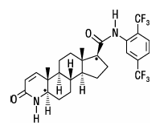
Systematic (IUPAC) name
(5α, 17β)-N-{2,5 bis(trifluoromethyl) phenyl}-3-oxo-4-azaandrost-1-ene-17-carboxamide
Identifiers
CAS number 164656-23-9
ATC code G04CB02
PubChem 152945
DrugBank APRD00385
Chemical data
Formula C27H30F6N2O2
Mol. mass 528.53 g/mol
Pharmacokinetic data
Bioavailability 60%
Protein binding 99%
Metabolism Hepatic (CYP3A4-mediated)
Half life 5 weeks
Excretion Fecal

