Enalapril Maleate (Cas No 76095-16-4)
Taj Active Pharmaceuticals Ingredients |  | www.tajapi.com
 |   Raw Material / Chemicals Index

Enalapril Maleate
CAS number CAS 76095-16-4
Structural Formula :
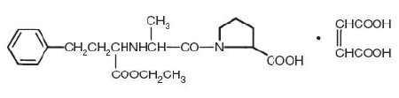
Enalapril Maleateis the maleate salt of enalapril, the ethyl ester of a long-acting angiotensin converting enzyme inhibitor, enalaprilat. Enalapril maleate is chemically described as (S)-1-[N-[1-(ethoxycarbonyl)-3-phenylpropyl]-L-alanyl]-L-proline, (Z)-2-butenedioate salt.
Its empirical formula is C20H28N2O5•C4H4O4. structural formula is:
Enalapril maleate is a white to off-white, crystalline powder with a molecular weight of 492.53. It is sparingly soluble in water, soluble in ethanol, and freely soluble in methanol.
Enalapril is a pro-drug; following oral administration, it is bioactivated by hydrolysis of the ethyl ester to enalaprilat, which is the active angiotensin converting enzyme inhibitor.
Enalapril maleate is supplied as 2.5 mg, 5 mg, 10 mg, and 20 mg tablets for oral administration. In addition to the active ingredient enalapril maleate, each tablet contains the following inactive ingredients: lactose, magnesium stearate, sodium bicarbonate, and starch. The 10 mg and 20 mg tablets also contain iron oxides.

