Eptifibatide (Cas No 188627-80-7)
Taj Active Pharmaceuticals Ingredients |  | www.tajapi.com
 |   Raw Material / Chemicals Index

Name Eptifibatide
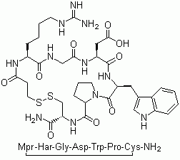
Synonyms N6-(Aminoiminomethyl)-N2-
(3-mercapto-1-oxopropyl-L-lysylglycyl-L-a-aspartyl-L-tryptophyl-L-prolyl-L-cysteinamide
Molecular Structure Eptifibatide, N6-(Aminoiminomethyl)-N2-
(3-mercapto-1-oxopropyl-L-lysylglycyl-L-a-aspartyl-L-tryptophyl-L-prolyl-L-cysteinamide,
CAS no.: 188627-80-7
Molecular Formula C35H49N11O9S2
Molecular Weight 831.96
CAS Registry Number 188627-80-7
Systematic (IUPAC) name
N 6 -(aminoiminomethyl)-N 2 -
(3-mercapto-1-oxopropyl-L-lysylglycyl-L-a-aspartyl-L- tryptophyl-L -prolyl-L-cysteinamide
Chemical data
Formula C35H49N11O9S2
Mol. mass 831.96 g/mol
Pharmacokinetic data
Bioavailability n/a
Protein binding ~25%
Metabolism ?
Half life ~2.5 hours
Excretion Renal

