Escitalopram (Cas No 128196-01-0)
Taj Active Pharmaceuticals Ingredients |  | www.tajapi.com
 |   Raw Material / Chemicals Index

Escitalopram
CAS number 128196-01-0
Structural Formula :
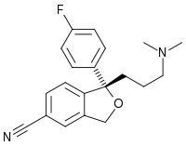
Systematic (IUPAC) name
(S)-1-[3-(dimethylamino)propyl]-1-(4-fluorophenyl)-1,3-dihydroisobenzofuran-5-carbonitrile
Identifiers
CAS number 128196-01-0
ATC code N06AB10
PubChem 146570
DrugBank APRD00683
ChemSpider 129277
Chemical data
Formula C20H21FN2O
Mol. mass 324.392 g/mol
(414.40 as oxalate)
SMILES eMolecules & PubChem
Pharmacokinetic data
Bioavailability 80%
Protein binding ~56%
Metabolism Liver, specifically the enzymes CYP3A4 and CYP2C19
Half life 27–32 hours
Escitalopramis the pureenantiomer of racemic citalopram and is a selective serotonin reuptake inhibitor (SSRI). Escitalopram is used in the treatment of depression and anxiety.

