Esomeprazole Magnesium (Cas No 161796-78-7)
Taj Active Pharmaceuticals Ingredients |  | www.tajapi.com
 |   Raw Material / Chemicals Index
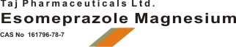
Esomeprazole Magnesium
CAS number 161796-78-7
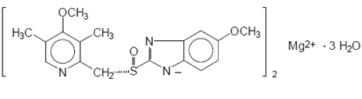
Systematic (IUPAC) name
(S)-5-methoxy-2-[(4-methoxy-3,5-dimethylpyridin-2-yl)
methylsulfinyl]-3H-benzoimidazole
Identifiers
CAS number 161796-78-7
ATC code A02BC05
PubChem 4594
DrugBank APRD00363
ChemSpider 7843322
Chemical data
Formula C17H19N3O3S
Mol. mass 345.417 g/mol
SMILES eMolecules & PubChem
Pharmacokinetic data
Bioavailability 50 to 90%
Metabolism Hepatic (CYP2C19, CYP3A4)
Half life 1–1.5 hours
Excretion 80% Renal
20% faecal

