Ethylmorphine HCl (Cas No 125-30-4)
Taj Active Pharmaceuticals Ingredients |  | www.tajapi.com
 |   Raw Material / Chemicals Index

Ethylmorphine HCl
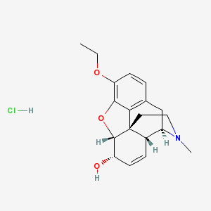
A synthetic toxic alkaloid that is an ethyl ether of morphine and is used especially in the form of its
hydrochloride C19H23NO3·HCl similarly to morphine and codeine
Ethyl-morphine hydrochloride, or dionine, is soluble in water and alcohol. In dose of 1/2 to 1 grain (0.003-0.06 gm.) it is not so sedative as its composition would seem to indicate, but it is employed more or less for cough and mild pain. It is analgesic in the eye, and has been extensively employed by the ophthalmologists in treatment of deep-seated ocular pain. Lloyd-Owen finds that a 2 to 5 per cent. solution dropped in the eye has scarcely any effect on the cornea and conjunctiva, but is decidedly analgesic in the presence of the deep-seated pains of iritis, glaucoma, etc. It does not contract the pupil. Several oculists have reported to me a primary irritation with chemosis lasting an hour or two. It is probable that its action is not local, and that it is absorbed through the eye to act on centers.

