Fexofenadine HC (Cas No 153439-40-8)
Taj Active Pharmaceuticals Ingredients |  | www.tajapi.com
 |   Raw Material / Chemicals Index

Fexofenadine HCl
CAS number 153439-40-8
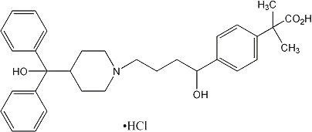
Systematic (IUPAC) name
2-[4-[1-hydroxy-4-[4-(hydroxy-diphenyl-
methyl)-1-piperidyl]butyl]phenyl]-2- methyl-propanoic acid
Identifiers
CAS number 153439-40-8
ATC code R06A626
PubChem 3348
DrugBank APRD00349
ChemSpider 3231
Chemical data
Formula C32H39NO4
Mol. mass 501.656
SMILES eMolecules & PubChem
Pharmacokinetic data
Bioavailability Not yet established
Protein binding 60-70%
Metabolism Hepatic (5% of dose)
Half life 14.4 hours
Excretion Biliary , fecal and renal

