Fluconazole (Cas No 86386-73-4)
Taj Active Pharmaceuticals Ingredients |  | www.tajapi.com
 |   Raw Material / Chemicals Index

Fluconazole
CAS number 86386-73-4
Structure Formula :
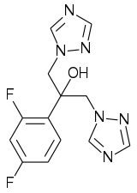
Systematic (IUPAC) name
2-(2,4-difluorophenyl)-
1,3-bis(1H-1,2,4-triazol-1-yl)propan-2-ol
Identifiers
CAS number 86386-73-4
ATC code D01AC15 J02AC01
PubChem 3365
DrugBank APRD00327
ChemSpider 3248
Chemical data
Formula C13H12F2N6O
Mol. mass 306.271 g/mol
Pharmacokinetic data
Bioavailability >90%
Protein binding 11–12%
Metabolism Hepatic 11%
Half life 30 hours (range 20-50 hours)
Excretion Renal 61–88%

