Fluoxetine Hcl (Cas No 54910-89-3)
Taj Active Pharmaceuticals Ingredients |  | www.tajapi.com
 |   Raw Material / Chemicals Index

Fluoxetine HCl
CAS number 54910-89-3
Structure Formula :
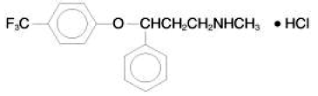
Systematic (IUPAC) name
N-methyl-3-phenyl-3-[4- (trifluoromethyl)phenoxy]propan-1-amine
Identifiers
CAS number 54910-89-3
ATC code N06AB03
PubChem 3386
DrugBank APRD00530
ChemSpider 56589
Chemical data
Formula C17H18F3NO
Mol. mass 309.3 g/mol (345.8 for •HCl)
Pharmacokinetic data
Bioavailability 72%
peak at 6-8 hours
Protein binding 94.5%
Metabolism Hepatic
Half life 1-3 days (acute); 4-6 days (chronic); Active metabolite Norfluoxetine 4-16 days (acute and chronic)
Excretion Kidneys 80%, intestines 15%

