Flurbiprofen (Cas No 5104-49-4)
Taj Active Pharmaceuticals Ingredients |  | www.tajapi.com
 |   Raw Material / Chemicals Index

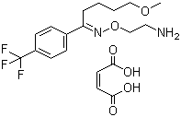
Fluvoxamine Maleate
Molecular Weight 434.41
Melting point 120-121.5 ºC
Systematic (IUPAC) name
(Z)-5-methoxy-1-[4-(trifluoromethyl)phenyl]pentan-1-one O-2-aminoethyl oxime
Identifiers
CAS number 54739-18-3
ATC code N06AB08
PubChem 5324346
DrugBank APRD00425
ChemSpider 4481878
Chemical data
Formula C15H21F3N2O2
Mol. mass 318.335
Pharmacokinetic data
Bioavailability 77%
Metabolism Hepatic
Half life 15.6 hours
Excretion Renal

