Galantamine Hbr (Cas No 1953-04-4)
Taj Active Pharmaceuticals Ingredients |  | www.tajapi.com
 |   Raw Material / Chemicals Index
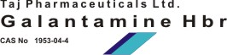
Galantamine HBr
CAS number 1953-04-4
Structure Formula :
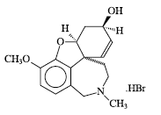
Synonyms:
Reminyl
Reminyl (TN)
6H-Benzofuro[3a,3,2-ef][2]benzazepin-6-ol,4a,- 5,9,10,11,12-hexahydro-3-methoxy-11- methyl-,hydrobromide,(4aS,6R,8aS)-
Prestwick_236
CAS Number:1953-04-4
Molecular Formula:C17H21NO3.HBr;C17H22BrNO3
Molecular Weight:368.27
EINECS:217-780-5
Galantamine Hydrobromideis galantamine hydrobromide, a reversible, competitive acetylcholinesterase inhibitor.
Galantamine hydrobromide is known chemically as (4aS,6R,8aS)-4a,5,9,10,11,12-hexahydro-3-methoxy-11-methyl-6H-benzofuro[3a,3,2-ef] [2]benzazepin-6-ol hydrobromide.
It has an empirical formula of C17H21NO3 •HBr and a molecular weight of 368.27. Galantamine hydrobromide is a white to almost white powder and is sparingly soluble in water.

