Gemcitabine HCL (Cas No 122111-03-9)
Taj Active Pharmaceuticals Ingredients |  | www.tajapi.com
 |   Raw Material / Chemicals Index
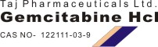
Molecular Structure
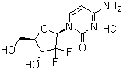
Name Gemcitabine hydrochloride
Synonyms 4-Amino-1-[3,3-difluoro-4-hydroxy-5-(hydroxymethyl)tetrahydrofuran-2-yl]-1H-pyrimidin-2-one hydrochloride
Molecular Formula C9H11F2N3O4.HCl
Molecular Weight 299.66
CAS Registry Number 122111-03-9
ATC code L01BC05
PubChem 60750
DrugBank APRD00201
Mol. mass 263.198 g/mol
Pharmacokinetic data
Bioavailability ?
Protein binding <10%
Metabolism ?
Half life Short infusions 32-94 minutes
for long infusions 245-638 minutes

