Glimepiride (Cas No 93479-97-1)
Taj Active Pharmaceuticals Ingredients |  | www.tajapi.com
 |   Raw Material / Chemicals Index

Molecular Structure
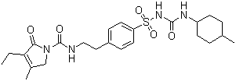
Molecular Formula C24H34N4O5S
Molecular Weight 490.62
CAS Number 93479-97-1
ATC code A10BB12
PubChem 3476
DrugBank APRD00381
Chemical data
Formula C24H34N4O5S
Mol. mass 490.617 g/mol
Pharmacokinetic data
Bioavailability ?
Protein binding >99.5%
Metabolism ?
Half life 5 Hours
Excretion Urine & Fecal
Systematic (IUPAC) name
3-ethyl-4-methyl-N-(4-[N-((1r,4r)-4-methylcyclohexylcarbamoyl)sulfamoyl]phenethyl)-2-oxo-2,5-dihydro-1H-pyrrole-1-carboxamide

