Ibuprofen (Cas No 15687-27-1)
Taj Active Pharmaceuticals Ingredients |  | www.tajapi.com
 |   Raw Material / Chemicals Index

Ibuprofen
CAS number 15687-27-1
Structure :
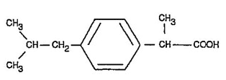
Systematic (IUPAC) name
2-(4-isobutylphenyl)propanoic acid
Identifiers
CAS number 15687-27-1
ATC code M01AE01
PubChem 3672
DrugBank APRD00372
ChemSpider 3544
Chemical data
Formula C13H18O2
Mol. mass 206.28
SMILES eMolecules & PubChem
Physical data
Melt. point 76 °C (169 °F)
Pharmacokinetic data
Bioavailability 49–73%
Protein binding 99%
Metabolism Hepatic (CYP2C9)
Half life 1.8–2 hours
Excretion Renal

