Irinotecan Hcl (Cas No 100286-90-6)
Taj Active Pharmaceuticals Ingredients |  | www.tajapi.com
 |   Raw Material / Chemicals Index

Irinotecan Hcl
Molecular Structure
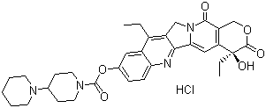
Molecular Formula C33H38N4O6.HCl
Molecular Weight 623.15
CAS Registry Number 100286-90-6
Melting point 250-256 ºC (dec.)
ATC code L01XX19
PubChem 3750
DrugBank APRD00579
Chemical data
Formula C33H38N4O6
Mol. mass 586.678 g/mol
677.185 g/mol (hydrochloride)
Pharmacokinetic data
Bioavailability NA
Metabolism Hepatic glucuronidation
Half life 6 to 12 hours
Excretion Biliary and renal

