Lercanidipine Hcl (Cas No 132866-11-6)
Taj Active Pharmaceuticals Ingredients |  | www.tajapi.com
 |   Raw Material / Chemicals Index
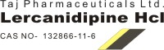
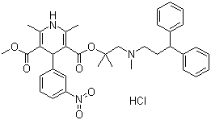
Lercanidipine Hcl
Molecular Formula C36H41N3O6.HCl
Molecular Weight 648.19
CAS Registry Number 132866-11-6
Systematic (IUPAC) name
2[(3,3-diphenylpropyl)(methyl)amino]-1,1-dimethylethyl methyl 2,6-dimethyl-4-(3-nitrophenyl)-1,4-dihydropyridine-3,5-dicarboxylate
Identifiers
CAS number 100427-26-7
ATC code C08CA13
PubChem 65866
DrugBank APRD00193
Chemical data
Formula C36H41N3O6
Mol. mass 611.727 g/mol
Pharmacokinetic data

