Loratadine (Cas No 79794-75-5)
Taj Active Pharmaceuticals Ingredients |  | www.tajapi.com
 |   Raw Material / Chemicals Index
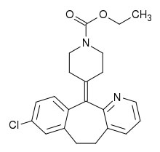

Loratadine
CAS number 79794-75-5
Systematic (IUPAC) name
Ethyl 4-(8-chloro-5,6-dihydro-11H-
benzo[5,6]cyclohepta[1,2-b]pyridin-
11-ylidine)-1-piperidinecarboxylate
Identifiers
CAS number 79794-75-5
ATC code R06AX13
PubChem 3957
DrugBank APRD00384
ChemSpider 3820
Chemical data
Formula C22H23ClN2O2
Mol. mass 382.88 g/mol
SMILES eMolecules & PubChem
Pharmacokinetic data
Bioavailability N/A due to extensive first-pass metabolism
Metabolism hepatic
Half life 8 hours (metabolites 12-24 hours)
Excretion 40% as conjugated metabolites into urine
similar amount into the feces
Therapeutic considerations
Pregnancy cat.
B1(AU) B(US)
Legal status
GSL(UK) OTC(US) OTC(Canada)
Routes oral

