Magnesium Valproate (Cas No 63372-86-1)
Taj Active Pharmaceuticals Ingredients |  | www.tajapi.com
 |   Raw Material / Chemicals Index

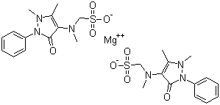
Name : Magnesium Valproate
Molecular Formula C26H32MgN6O8S2
Molecular Weight 645.00
CAS Registry Number 63372-86-1
Element category alkaline earth metal
Group, period, block 2, 3, s
Appearance silvery white solid at room temp
Standard atomic weight 24.3050(6) g·mol−1
Electron configuration [Ne] 3s2
Electrons per shell 2, 8, 2 (Image)
Physical properties
Phase solid
Density (near r.t.) 1.738 g·cm−3
Liquid density at m.p. 1.584 g·cm−3
Melting point 923 K
(650 °C, 1202 °F)
Boiling point 1363 K
(1091 °C, 1994 °F)
Heat of fusion 8.48 kJ·mol−1
Heat of vaporization 128 kJ·mol−1
Specific heat capacity (25 °C) 24.869 J·mol−1·K−1

