Meropenem (Cas No 119478-56-7)
Taj Active Pharmaceuticals Ingredients |  | www.tajapi.com
 |   Raw Material / Chemicals Index

Meropenem
CAS number 119478-56-7
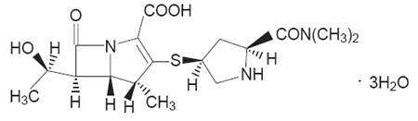
Systematic (IUPAC) name
3-[5-(dimethylcarbamoyl) pyrrolidin-2-yl] sulfanyl-6- (1-hydroxyethyl)-4-methyl-7-oxo- 1-azabicyclo[3.2.0] hept-2-ene-2-carboxylic acid
Identifiers
CAS number 119478-56-7
ATC code J01DH02
PubChem 64778
DrugBank APRD01097
Chemical data
Formula C17H25N3O5S
Mol. mass 383.464 g/mol
Pharmacokinetic data
Bioavailability 100%
Protein binding Approximately 2%.
To reduce the development of drug-resistant bacteria and maintain the effectiveness ofmeropenem for injectionand other antibacterial drugs,should be used only to treat or prevent infections that are proven or strongly suspected to be caused by bacteria.
meropenem for injectionis a sterile, pyrogen-free, synthetic, broad-spectrum, carbapenem antibiotic for intravenous administration. It is (4R,5S,6S)-3-[[(3S,5S)-5- (Dimethylcarbamoyl)-3-pyrrolidinyl]thio]-6-[(1R)-1-hydroxyethyl]-4-methyl-7-oxo-1- azabicyclo[3.2.0]hept-2-ene-2-carboxylic acid trihydrate. Its empirical formula is C17H25N3O5S•3H2O with a molecular weight of 437.52.
The solution varies from colorless to yellow depending on the concentration. The pH of freshly constituted solutions is between 7.3 and 8.3. Meropenem is soluble in 5% monobasic potassium phosphate solution, sparingly soluble in water, very slightly soluble in hydrated ethanol, and practically insoluble in acetone or ether.

