Metamizol Magnesium (Cas No 6150-97-6)
Taj Active Pharmaceuticals Ingredients |  | www.tajapi.com
 |   Raw Material / Chemicals Index

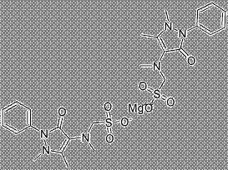
Metamizol Magnesium
CAS No. 6150-97-6
Molecular Formula: C26H32MgN6O8S2
Effects of metamizol and magnesium sulfate on enzyme activity of glucose 6-phosphate dehydrogenase from human erythrocyte in vitro and rat erythrocyte in vivo.
Chemical data
Formula C13H16N3NaO4S
Mol. mass 311.358 g/mol
Pharmacokinetic data
Bioavailability ?
Metabolism AM404, P Cytochrome P 450, glutation
Half life 1 - 4 hours
Excretion renal

