Methylphenidate Hcl (Cas No 113-45-1)
Taj Active Pharmaceuticals Ingredients |  | www.tajapi.com
 |   Raw Material / Chemicals Index

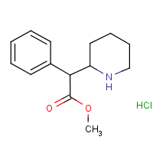
Methylphenidate Hcl
CAS number 113-45-1
ATC code N06BA04
PubChem 4158
DrugBank APRD00657
ChemSpider 4015
Chemical data
Formula C14H19NO2
Mol. mass 233.31 g/mol
SMILES eMolecules & PubChem
Pharmacokinetic data
Bioavailability 11–52%
Protein binding 30%
Metabolism Liver
Half life 2–4 hours
Excretion Urine

