Metoprolol Tartrate (Cas No 56392-17-7)
Taj Active Pharmaceuticals Ingredients |  | www.tajapi.com
 |   Raw Material / Chemicals Index

Molecular Structure
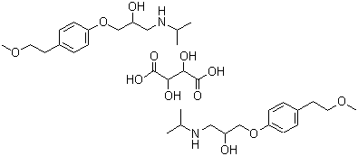
Metoprolol Tartrate
Molecular Formula 2(C15H25NO3).(C4H6O6)
Molecular Weight 684.81
CAS Number 56392-17-7
Mol. mass 267.364 g/mol
SMILES eMolecules & PubChem
Pharmacokinetic data
Bioavailability 12%
Metabolism Hepatic
Half life 3-7 hours
Excretion Renal

