Metroprolol succinate (Cas No 98418-47-4)
Taj Active Pharmaceuticals Ingredients |  | www.tajapi.com
 |   Raw Material / Chemicals Index

Molecular Structure
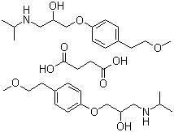
Name Metroprolol succinate
CAS NO 98418-47-4
Molecular Formula 2(C15H25NO3).C4H6O4
Molecular Weight 652.83
ATC code C07AB02
PubChem 4171
DrugBank APRD00208
ChemSpider 4027
Chemical data
Formula C15H25NO3
Mol. mass 267.364 g/mol
SMILES eMolecules & PubChem
Pharmacokinetic data
Bioavailability 12%
Metabolism Hepatic
Half life 3-7 hours
Excretion Renal

